Light Sport Version

Pilot Operating Handbook

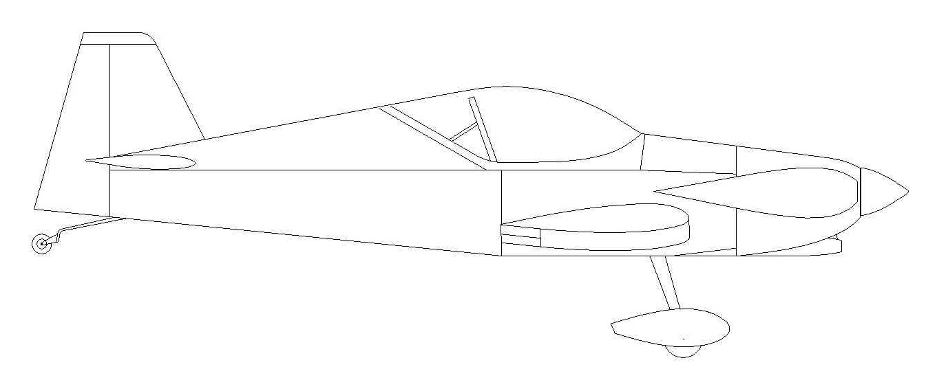

Sport Performance Aviation LLC
1528 Virgils Way, Suite 8
Green Cove Springs, FL 32043
www.FlywithSPA.com
Support@FlywithSPA.com
904.626.7777
Contents
Panther Aircraft Data 1
Introduction 1
Panther General Information 3
Drawings and Specifications 3
Panther Side View 3
Panther Front View 3
Panther Top View 4
SPECIFICATIONS 4
Placards 6
Speeds 6
Load Factor 6
Engine Limitations 6
Checklists 7
Engine Start Checklist 9
Take Off Checklist 9
Run Up Checklist 10
Cruise Checklist – See Panther Flying Qualities 10
Landing Checklist 10
Shut Down Checklist 11
Emergency Checklist 11
Engine Fire 11
Electrical Fire 12
Engine out 12
Weight and Balance 13
Terminology 13
Weight and Balance Calculation 15
Airplane and Systems Description 16
Construction 16
Airframe 16
Wings 16
Propeller 16
Landing Gear 16
Cabin Access 17
Seats 17
Baggage 17
Flight Instruments and Avionics 17
Radio 17
Avionics 17
Controls 18
Brakes 18
Rudder Pedals 18
Control Stick 18
Flaps 18
Fuel Systems 18
Fuel Selector 19
Throttle Quadrant 19
Elevator trim (outer black knob)- 19
Throttle (middle black knob)- 19
Mixture (inner red knob 20
Carburetor Heat 20
Switches 20
Ignition / Fuel Pump Switches- 20
Master Switch 20
Avionics Switch 20
Circuit Breakers 20
IGN (Ignition) 21
FP (Fuel Pump) 21
Avionics 21
GEN (Generator) 21
Engine Cowling 21
Pitot and Static Pressure 21
Electrical System 21
Panther LS Performance Information 22
General 22
Take-off 22
Cruise 23
Stall/Slow Flight 23
Aerobatics 23
Landing 24
Maintenance 25
Inspection Schedules 26
Every 25 hours 26
Every 100 hours or six months (whichever comes first) 28
Conditional Inspection 28
Tie-Down 29

Panther Aircraft Data

Aircraft Type: Panther LS

Manufacturer: Daniel E Weseman

Kit provided by: Sport Performance Aviation LLC

Registration Number: N515XP

Aircraft Serial Number: P001

Engine type: Corvair 3.0L

Engine Serial Number: WW12051575

Propeller: Sensenich WC62FKL-54S

Introduction

Note: This POH is For N515XP. Use this as an example and modify to fit your needs.
Other “Panthers” may not operate like each other, or per this POH. Performance and Operation of other aircraft should be carefully evaluated during the Phase 1 test time.

Note: If an ambiguity exits between this manual and any Federal regulations or general aircraft operating principles, the latter will supersede.

This manual is intended to be read together with the Engine Manual of the installed power plant. The information contained in the Engine Manual is not repeated here as the engine manufacturer recommendations should be followed at all times.

To obtain the best performance from and flying enjoyment from SPA Panther, familiarize yourself thoroughly with the aircraft, its equipment, systems, and controls. Proper and efficient operation of the aircraft requires a competent licensed pilot. It is important to obtain adequate training on this type of aircraft before attempting to pilot the airplane.

Copyright © 2016 Sport Performance Aviation LLC. All rights reserved.
No parts of this work may be reproduced in any form or by any means - graphic, electronic, or mechanical, including photocopying, recording, taping, or information storage and retrieval systems - without the written permission of the publisher.

Designs, products, parts or items that are referred to in this document may be either trademarks and/or registered trademarks of the respective owners.

While every perceived precaution has been taken in the preparation of this document, the publisher and the author assume no responsibility for errors or omissions, or for damages, including death, resulting from the use of information contained in this document or from the use of products, parts or items that may accompany it. In no event shall the publisher and the author be liable for any loss of property or any other damage, harm or death caused or alleged to have been caused directly or indirectly by this document.

Panther General Information

Drawings and Specifications

Panther Side View

Panther Front View

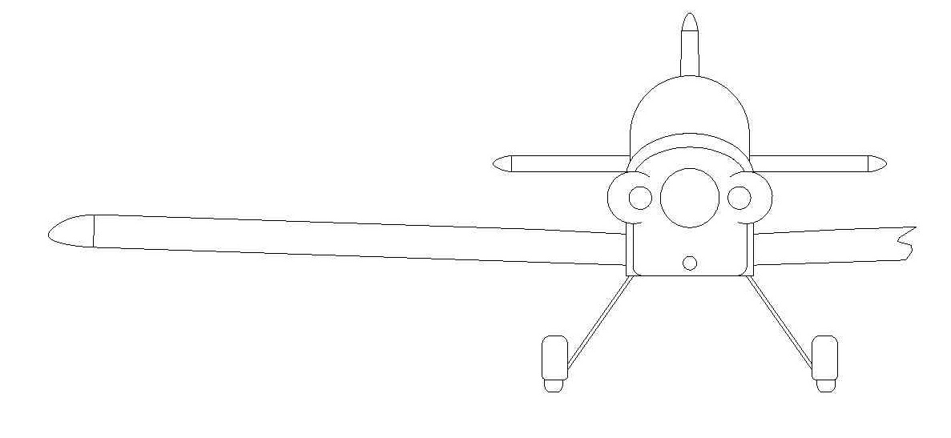

Panther Top View
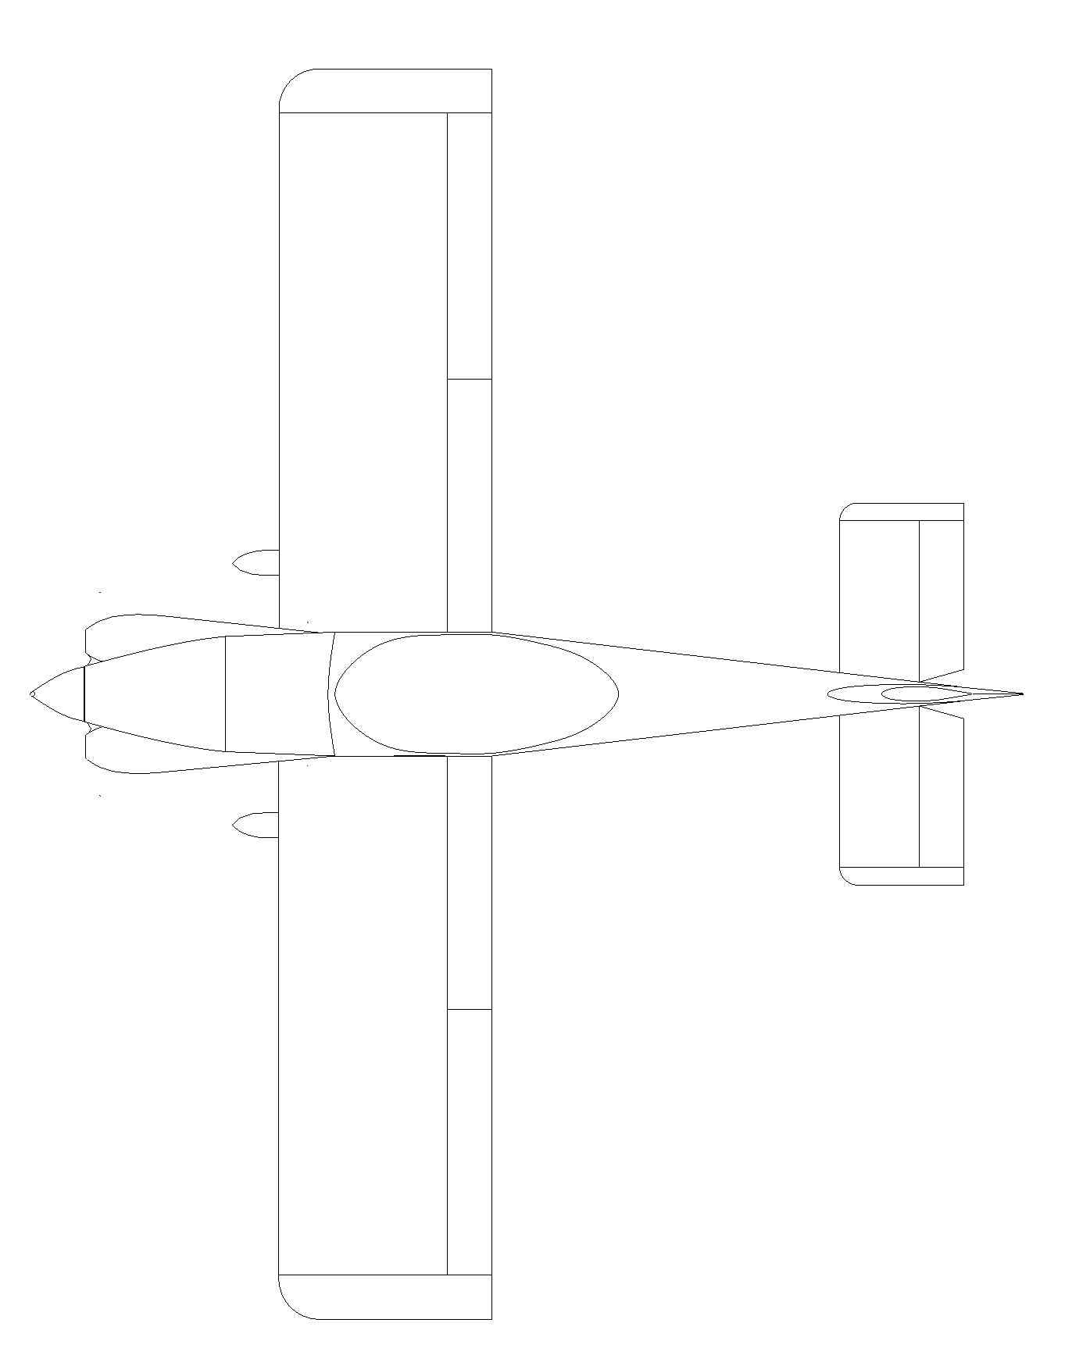

SPECIFICATIONS
Wing span | 23.5 ft
Wing area | 93 sqft
Length | 19 ft
Empty weight | 754 lbs
Useful load (as LSA) | 361 lbs
Gross weight (as LSA) | 1,115 lbs
Wing Loading | 11.99 psf
Power Loading | 10lb/hp
V_{NE} | 200 mph
Design Load Factor | +6 / - 3 "G"
Cabin Width | 28 Inches
Fuel Capacity (total) | 27.5 gallons
Baggage Capacity | 30 lbs max/as allowed by CG

Placards

The aircraft are placarded as follows:

- All Circuit Breakers / Fuses
- All Switches
- Throttle
- Mixture
- Trim
- Fuel Shut-off Valve
- Fuel Type and Quantity
- Stainless Steel ID Plate
- Oil Type and Quantity

Speeds

Assumes 1115 lb. gross weight, mid-range CG, and standard sea level conditions:

V_{ne} | (never exceed speed) | 200 mph
V_{a} | (never exceed speed) | 138 mph
V_{fe} | (flap extension) | 100 mph
V_{x} | (best angle of climb speed) | 69 mph
V_{y} | (best rate of climb speed) | 85 mph
V_{s} | (stall speed) | 51 mph

Load Factor

Load Factors are 6 G positive and 3 G negative. The ultimate load factors are multiplied by the safety factor of 1.5.

Engine Limitations

Refer to Engine Manual

Checklists
Pre-flight

- Cockpit
- Verify qty 2 main wing pins, and safety pins installed
- Verify aft pins installed and locked
- Verify left and right fuel supply lines properly connected.
- Flaps down
- Verify controls free and proper.
- Inspect landing gear fasteners and upper legs for condition.
- Inspect brake lines
- Inspect rudder and brake pedals
- Inspect control stick, control stick block, and associated bearing, pushrods, and rod ends for condition and security
- Inspect seat belts
- Inspect aileron joiner “paddles” and associated pushrod and rod ends for condition and security
- Verify no loose items in cockpit or baggage area.

Engine
- Remove upper cowl and check oil is in between full and low marks
- Visually inspect engine compartment
- Inspect engine mount, intake system, and exhaust for security and condition.
- Inspect fuel and oil line and system for condition, leaks and chafing.
- Inspect propeller and spinner
- Inspect spark plug, ignition and other wirers wires components
- Reinstall upper cowl

Fuel system
- Take and inspect fuel sample from each wing fuel tank low point drain
- Visually check each fuel tank quantity, and note fullest tank
- Set fuel selector valve to fullest tank
- Turn on one IGN/FP
- Take and inspect fuel sample from carburetor float bowl low point drain. Verify drain is closed and not leaking.
- Turn off IGN/FP

Left landing gear
- Inspect left gear leg for cracks and security.
- Inspect brake line (rear of leg)
- Inspect wheel pants for cracks, loose/missing fasteners, security
- Inspect tire for wear and proper inflation (30 lbs.)

Left Wing
- Inspect for damage, corrosion and loose rivets or fasteners
- Inspect fuel tank for leaks, condition, and security
- Remove Pitot tube cover, stow in map pocket, and inspect Pitot tube for security
- Inspect fiberglass tip for condition and security
- Inspect aileron.
- Verify aileron hinge pin secured
- Inspect flap
- Verify flap hinge pin safety
- Inspect flap drive system.

Left tail cone side
- Inspect left tail cone side for loose fasteners, rivets, corrosion, and condition.
- Inspect tail cone belly

Tail Group

- Inspect tail group for loose fasteners, rivets, corrosion, and condition
- Verify elevator pin safety verify rudder pin safety
- Inspect elevator control rod end and control horn.
- Inspect tail wheel spring and tail wheel assembly
- Inspect tail wheel steering pushrod

Right tail cone

- Inspect right tail cone side for loose fastener, rivets, corrosion, and condition.
- Inspect tail cone belly

Right wing
- Inspect for damage, corrosion and loose rivets or fasteners
- Inspect fuel tank for leaks, condition, and security
- Inspect fiberglass tip for condition and security
- Inspect aileron.
- Verify aileron hinge pin secured
Inspect flap
- Verify flap hinge pin safety
- Inspect flap drive system.

Right landing gear
- Inspect right gear leg for cracks and security.
- Inspect brake line (rear of leg)
- Inspect wheel pants for cracks, loose/missing fasteners, security
- Inspect tire for wear and proper inflation (30 lbs.)

Engine Start Checklist

- Pre-flight checklist conducted
- Close canopy
- Latch canopy (taxi or flight position)
- Master switch “ON”
- Select fuel tank
- IGN/Fuel Pumps
- Throttle ½ inch
- Clear prop
- Start engine
- Avionics power switch “ON” (wait for EFIS align before taxi)
- Switch on radio, select proper frequency

Take Off Checklist

- Select fuel tank (most full)
- Check fuel pressure
- Check fuel gauges
- Verify wing pins (4) and fuel line connection(2)
- Check control stick for free movement
- Set trim
- Set flaps (up 1 notch)
- Transponder set
- Set altimeter
- Seat belts fastened

Run Up Checklist

- Oil pressure > 30 psi
- Oil temperature > 120 F
- Throttle to 1,800 RPM
- Check ignitions - max 100 rpm drop
- Check carb heat – 50 RPM drop expected
- Check oil pressure – 35 psi min
- Both IGN/FP ON
- Latch canopy to flight position

Raise Tail | 15-20 MPH
Rotate | 60-65 MPH
Initial Climb | 75-85 MPH (until clear of obstacles
Climb | 100-110 MPH
Cruise Climb | 110-130 MPH

Cruise Checklist – See Panther Flying Qualities

Landing Checklist

- Select proper tank (most full)
- Both IGN/FP switches on
- Mixture full rich
- Carb heat “ON” – below 2000 RPM use slow application of power
- Set trim
- Flaps / Slips as required
Note: slips should be made with “supply” tank up
- *Note* – MUST USE carburetor heat for slow flight and stalls. Use slow application of power after periods of idle RPM (under 2000 RPM).

 | 3 point | Wheel
Initial approach | 150 MPH | 150 MPH
Downwind | 110-120 MPH | 110-120 MPH
Base – full flaps | 65-70 MPH | 75 MPH
Final | 65 MPH | 75 MPH
Touchdown | 60 MPH | 65 MPH

- Close carb heat before taxi

Shut Down Checklist

- Mixture full lean
- IGN/FP switches “OFF”
- Avionics switch “OFF”
- Master switch “OFF”

Emergency Checklist

Engine Fire

- Turn fuel valve to “OFF”
- Adjust air inlet vents as required
- Find landing site
- Shut engine off (if necessary)
- Land as soon as possible

Electrical Fire
- Turn master switch to “OFF
- Adjust air inlet vents as required
- Quick Release Canopy if needed

Engine out
- Establish best glide speed (trim)
- Find landing site
- If time allows – try engine re-start (pull throttle to idle, press starter button)
- Both IGN/FP switches on
- Switch fuel tanks
- Carb heat
- If Engine Won’t Start
  - Turn fuel valve to “OFF”
  - Switch both IGN/FP to “OFF”
**NOTE – Remember!! Never stop flying the airplane!

Weight and Balance

Terminology

DATUM: (Reference Datum). The imaginary vertical line from which all horizontal measurements are taken for weight and balance purposes with the aircraft in level flight attitude. The datum is 60 inches in front of the leading edge (L.E.) of the wing. All moment arms and the location of the permissible C.G. range must be taken with the reference to the datum.

ARM: The horizontal distance from the reference datum line to the center of gravity of the item. The algebraic sign is plus (+) if measured aft of the datum, and minus (-) if measured forward of the datum.

MOMENT: The product of the weight of an item multiplied (x) by its arm.

CENTER OF GRAVITY: (C.G.).
The point about which the aircraft would balance, if it were possible to suspend it at that point.

CENTER OF GRAVITY LIMITS:
The specified forward and aft points between which the C.G. must be located during takeoff, flight, and landing.
- Normal Range
  - Panther N515XP When flown throughout the “Normal” CG range is easy to fly, has light, but not “twitchy” stick forces.
- Toward forward end of the range the aircraft
  - will not fully Stall or Spin easily.
  - It will have good positive stability, but be less maneuverable, and have higher Pitch stick forces.
- Toward the aft end of the “Normal” range the Panther
  - will Stall fully, And Spin If full control is held (see Aerobatic section).
  - The Pitch stick forces will be slightly lower. It will retain good Positive stability.
- Caution:

  - In the “Caution” Range Panther N515XP will have progressively lighter stick forces as the CG moves aft.
  - Stall and Spin Recovery is positive at the Aft “Caution” limit.
  - Spins will be slightly more nose high, and at a lower rotation rate than at mid CG ranges.
  - Pitch Stick forces are very light especially at low speed.
  - At the aft “Caution” limit N515XP retains positive stability at all speeds.
- We recommend test flying in the Normal Range then expanding the envelope to the caution Range during Phase 1 testing.

Weight and Balance Calculation

Empty Weight | 754lbs
Gross Weight | 1,115lbs
Useful Load | 361lbs
* Fuel loading in gal (US) |  | (for calculation into lbs: x 6)
 | Weight | Arm | Moment
Empty Airplane |  | 69.77 ''
Pilot* |  | 84.25-89.75”
Fuel |  | 67 ''
Baggage Compartment  (max. 30 lbs) |  | **
*Depending on pilot seat position
** Measure or estimate distance from, aft lower fuse tube to center of baggage, and add 108”

Total

Max. Gross Weight: (LSA) 1,115 lbs
Forward Limit: 69.60 (20%)
Rear Limit – Normal: 74.40 (30%)
Rear Limit – Caution: 75.60 (32.5%)

Airplane and Systems Description

Construction

All-metal construction, stressed skin, single curvature metal skins riveted to stiffeners.

Airframe

The forward airframe is constructed from welded and powder coated 4130 chrome-moly steel. The rest of the airframe is constructed from 6061-T6 aluminum sheet and extrusion. Components are assembled using AN hardware, aluminum and stainless steel pulled rivet components.

Wings

The wing has a NACA 23015. The wings are fitted with ailerons and flaps. Each wing features a leading edge fuel tank holding 13.5 gallons (13 usable)

The wings can be folded and stowed against the side of the fuselage by one person in less than ten minutes.

Propeller

The Panther N515XP is equipped with a Sensenich Composite over wood, fixed pitch propeller. See also Manuals / Others / Propeller.

Landing Gear

The gear is fabricated from 7075 T-6 aluminum and bolts to the welded steel fuselage cage. It is equipped with Matco hydraulic toe brakes. The tail wheel is a steerable full-caster-ing unit from API. Using full rudder and brake application in the direction of the turn allows full caster-ing. For ground maneuvering gently pushing sideways on the tail will allow it to caster.

Cabin Access

The cockpit is accessed from the left side of the aircraft. The canopy is hinged on the right and opens from the left side only.

Seats

Seat cushions are removable for easy cleaning and drying. The seat back and bottom can be easily moved to accommodate various sized pilots and preferred seating position. The Panther has a Crow Enterprises 5-point harness system installed.

Note: Prior to each flight, ensure that the seat belts are firmly secured to the airframe, and that the belts are not damaged. Adjust the buckle so that it is centered on the body.

Baggage

The area behind the seat serves as a baggage compartment. The maximum loading is 30 lbs.15 lbs on each side of “pushrod tube cover” and distributed evenly across the floor. In order to prevent the baggage from shifting during flight all items must be secured before flight.
No aerobatics,and a +4.4/-2.2 G limit with anything in baggage area

Flight Instruments and Avionics

Radio
The radio in the Panther is a FlightLine FL760 transceiver. This unit has an instrument panel insert for headphones, microphone and audio input. See the FL760 manual for more information.

Avionics
Grand Rapids Technologies (GRT) Sport SX with an 8.4” screen. This unit provides the EFIS, GPS, Synthetic Vision and engine instruments. See the GRT Sport SX manual for more information.

Controls

Brakes
The Panther features independent hydraulic brakes with master cylinders located on each rudder pedal.

Rudder Pedals
Adjusters are located in the rudder cables next to the seat to give three quick rudder pedal adjustments.
The rudder pedals pivot points can be easily moved fore/aft and vertically by removing the bonnet and relocating the pedals and master cylinders by moving the pivot bolts.

Control Stick
The stick controls the elevator and the ailerons through push/pull tubes, with ball bearing pivot points. There is a direct link connecting the stick to the elevator, and paddles connecting the stick to the ailerons.

Flaps
Flaps are operated by a handle at the left side of the seat. Press the button on the top and lift the handle to the desired flap setting.

Fuel Systems

The fuel tanks are located in the leading edge of each wing with a capacity of 13.5 US gallons per tank. The fuel tanks are vented at the wing root rib.

Tank drain valves are located under each wing and one on the carburetor body.

See diagram:

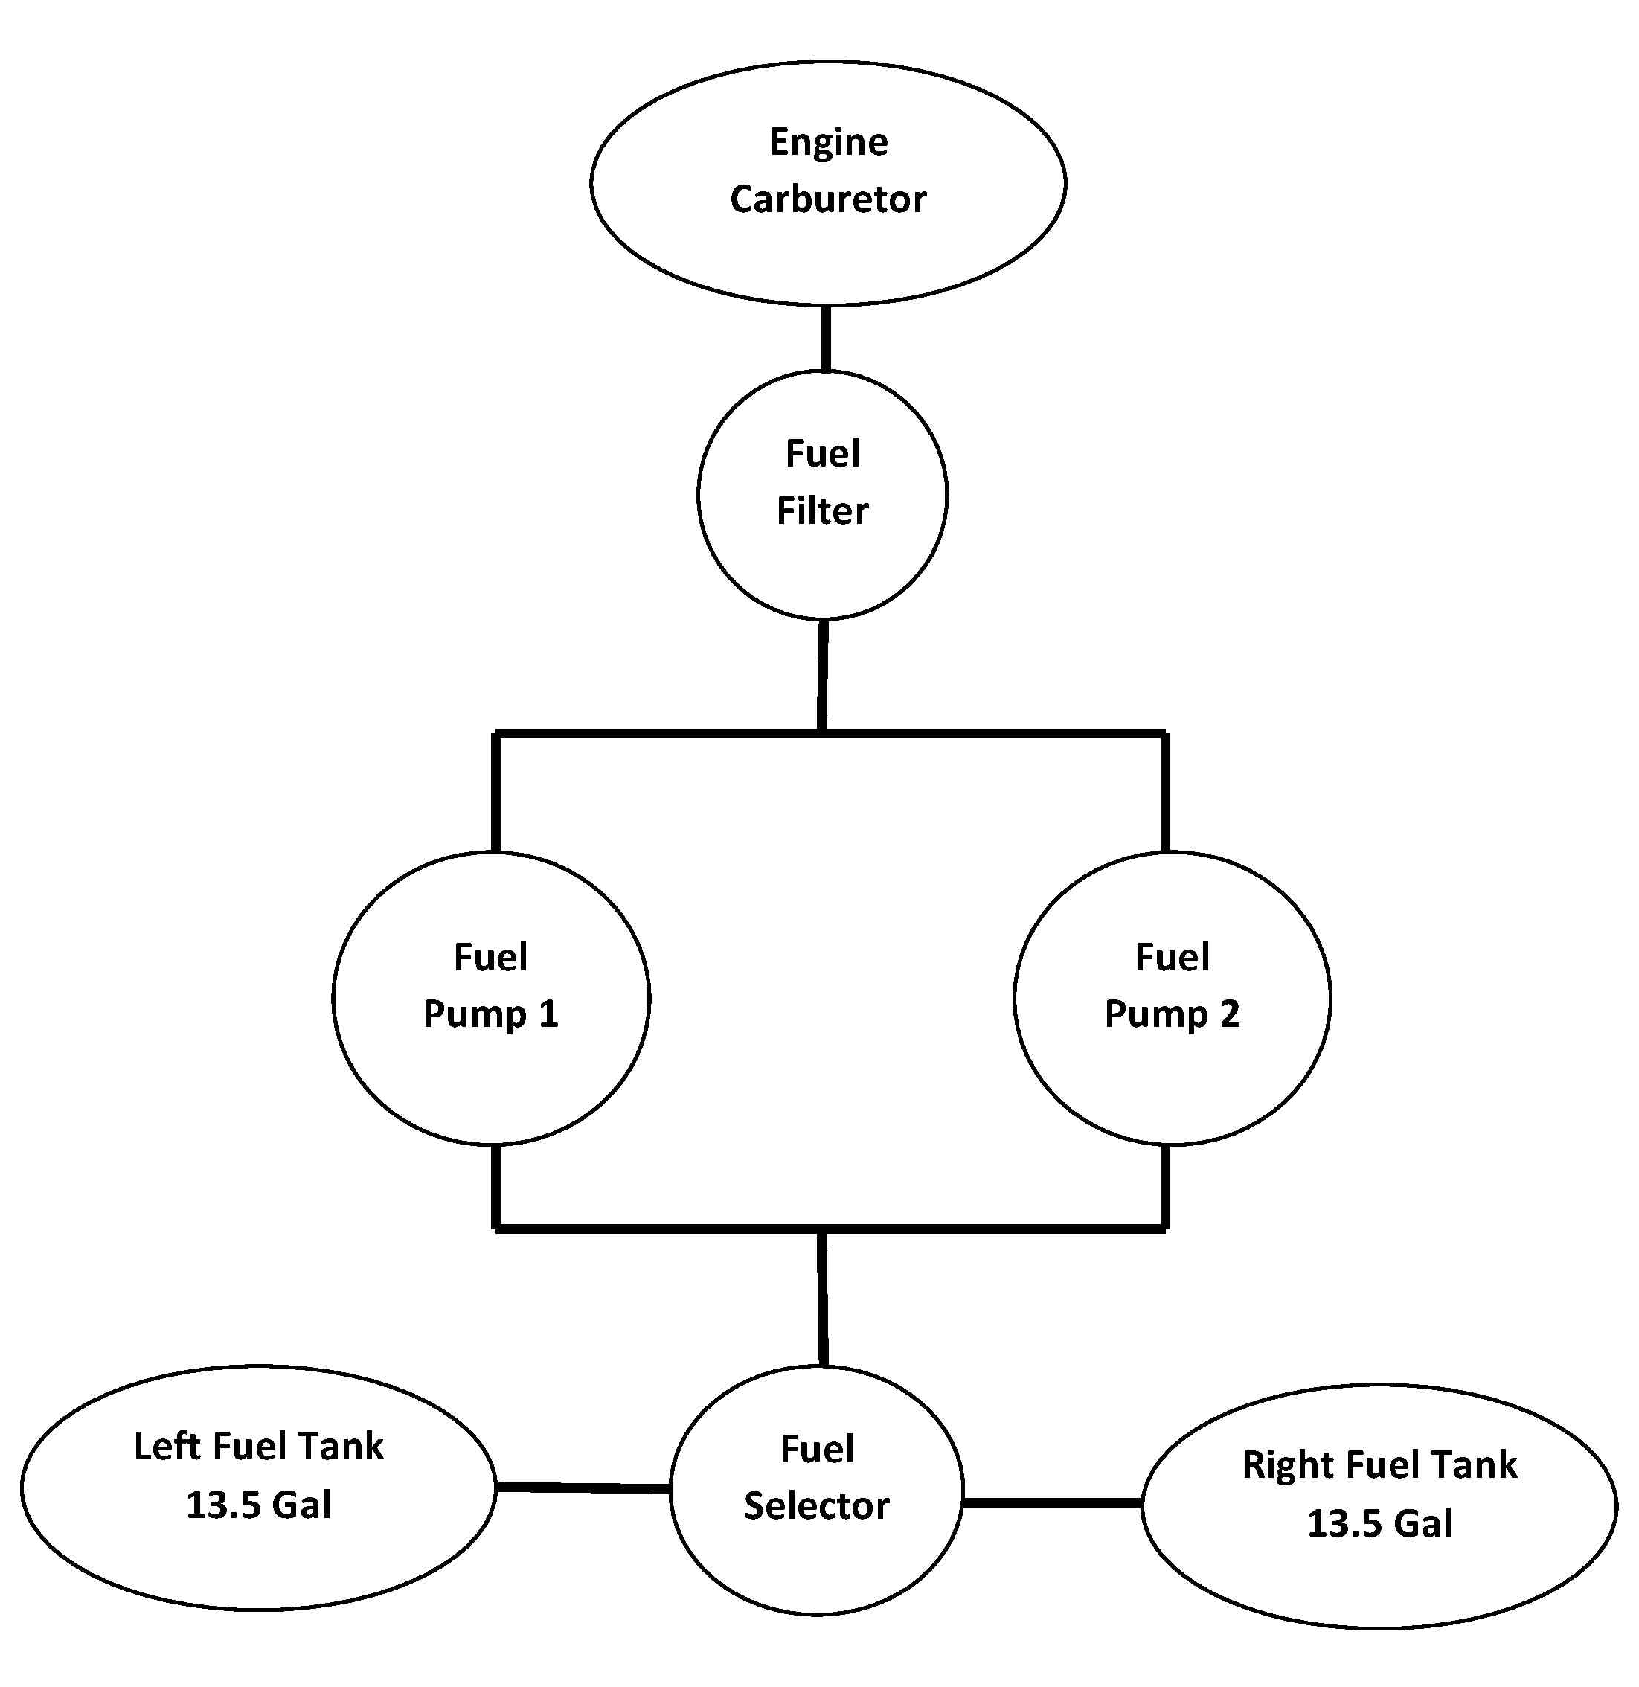

Fuel Selector

The Fuel Selector Lever is located in front of the main spar and connects either the left or right fuel tank to the engine. See also the chapter “Fuel System” in this manual.

Throttle Quadrant

A three lever throttle quadrant is mounted on the left side of the cockpit. It contains the throttle, mixture, and elevator trim controls.

Elevator trim (outer black knob) - Push forward to lower nose, pull back raise nose.

Throttle (middle black knob) - Push forward to increase engine RPM, pull back to decrease engine RPM.

Mixture (inner red knob) - Push forward to increase carburetor mixture, pull back to decrease carburetor mixture.

Carburetor Heat

Carburetor heat is to be used during landings or whenever carb ice may be an issue. It is controlled with the black knob just below the instrument panel and on the left side wall. Pulling the knob out applies carburetor heat, and pushing the knob in removes carburetor heat.

Switches

Ignition / Fuel Pump Switches-

There are two Ignition Switches, labeled IGN/FP 1 and IGN/FP 2. Placing an IGN/FP Switch in the ON position provides power to one ignition and one fuel pump.

Note: Both Ignition Switches should be on for engine start, take-off, and landing.

Master Switch

The Master Switch is located on the lower left of the instrument panel. This switch decouples every circuit (except the ignition circuits and fuel pumps for the Corvair engine) from the 12 Volt battery by means of a master solenoid.

Note: While the Master Switch must be in the ON position to start the engine, the engine will run with Master Switch in the OFF position but none of the electrical equipment will operate.

Avionics Switch
The Avionics Switch provides power to the Radio, EFIS/GPS, EIS.

Circuit Breakers

There are six circuit breakers in the Panther instrument panel:

IGN (Ignition)
There are two 4A circuit breakers labeled IGN. One is above the IGN/FP 1 switch, and the other is above the IGN/FP 2 switch. Pulling an IGN breaker will remove power to that ignition.

FP (Fuel Pump)
There are two 4A circuit breakers labeled FP. One is above the IGN/FP 1 switch, and the other is above the IGN/FP 2 switch. Pulling an IGN breaker will remove power to that fuel pump.

Avionics
The 10A circuit breaker feeds power to the Avionics Switch.

GEN (Generator)
The 35A circuit breaker is located between the output of the generator and the battery.

Engine Cowling

The top half of the cowling is removed by removing the screws that secure it to the upper firewall and the lower cowling

The lower half is removed releasing the screws that secure it to the lower firewall and removing the scat tubing from the air filter box.

Pitot and Static Pressure

Both pitot and static pressure are provided by the pitot tube under the left wing. Ensure that tubes are not kinked when unfolding and inserting the wing spars into the center section spar box.

Note: Blowing into the tube will damage the airspeed indicator.

Electrical System
Gascolator
Fuel Pump
Fuel Pump
Fuel Filter
Fuel Selector
Right Fuel Tank

The airplane is equipped with a 12 Volt electrical system fed by an 18 amp-hr battery (located aft of the pilot seat on the right side wall) and an engine driven generator/regulator. The electrical system is operated by the master switch.

The electrical system is protected by circuit breakers located on the instrument panel.

Panther LS Performance Information

General

The Panther a light weight sport aircraft. It is easy to fly combining light control pressures without over sensitivity. Its light weight and generous wing area give it excellent performance on the available power.

Take-off

After aligning with the runway smoothly apply power

Raise Tail | 15-20 MPH
Rotate | 60-65 MPH
Initial Climb | 75-85 MPH (until clear of obstacles
Climb | 100-110 MPH
Cruise Climb | 110-130 MPH

Cruise
 | RPM | MPH
Max – Continuous | 2850 | 138
Max RPM | 3350 | 170
8000 Ft | 2850-3350 | 150-165 TAS

Stall/Slow Flight

Clean | 51 MPH Sea Level TAS
Clean | 56 MPH IAS
Dirty | 52 MPH IAS

*Note* – MUST USE carburetor heat for slow flight and stalls. Apply power slowly after periods of idle RPM (under 2000 RPM).

Aerobatics

Loops | 100-150 MPH
Rolls – aileron/barrel | 100-150 MPH
Snap Rolls | 95-110 MPH
Spins | full stall full aft elevator full rudder in direction of spin
Recovery | neutral elevator, full rudder to stop rotation

*Note* – The Panther is spin resistant when flown at forward CG ranges and full controls must be held to enter and maintain spin. Neutralizing controls will result in spin recovery. Use Caution not to let Spins develop into “Spiral Dives”

Landing

 | 3 point | Wheel
Initial approach | 150 MPH | 150 MPH
Downwind | 110-120 MPH | 110-120 MPH
Base – full flaps | 65-70 MPH | 75 MPH
Final | 65 MPH | 75 MPH
Touchdown | 60 MPH | 65 MPH

Maintenance

The Panther is an all metal aircraft built from high strength aviation grade aluminum alloys (6061-T6), which has good corrosion resistant characteristics, and powder coated 4130 chrome-moly steel.

If the airframe is painted the paint coating should keep its high gloss for many years when sponged with water. A cup of dishwasher liquid in a pail of water will help remove unwanted dirt. Always rinse thoroughly with fresh water after washing.

If the airframe is polished, normal maintenance will consist of washing as above, and re-polishing annually to maintain a bright, mirror finish.

The following maintenance program outlines the minimal maintenance which must be followed to keep the aircraft in good flying condition. The suggested time interval of 25 hours does not in any way eliminate the need for routine maintenance before and after each flight. Maintenance is part of the part of the pilot’s responsibilities: the pilot should be assured that the aircraft is airworthy at all times. The recommended 25 and 100 hour maintenance checks are designed to cover areas frequently neglected in the quicker preflight inspection, and serve only as a useful indication of the required maintenance.

Note: Record all maintenance and repairs in the Aircraft Log Book

Inspection Schedules

Every 25 hours

Check the general condition of the Panther and in particular, the following:

General: Verify, that no cables are chafed, check for proper anchorage and attachment of all items (fuel, coolant, oil lines and electrics, etc.). Verify that all fasteners and pins have the required “safety”.

Controls: Check for rust on steel parts (clean and repaint as required). Lubricate all moving parts (hinges, control attachments, bearings, etc.). Verify that all controls operate smoothly and that they are firmly attached.

Landing Gear: Inspect fuselage and axle attach points. Check brake lines.

Wheels: Inflate tires to 30 psi. Check the tire wear, rims, braking system and lines.

Cockpit interior: Clean with household cleaners according to the materials.

Canopy: The canopy is a single piece Plexiglas bubble. Use only cleaners designed for Plexiglas to prevent crazing. Do not use gasoline, alcohol, oil, lacquer, benzene, acetone, paint thinner, etc. A suitable cover is suggested to protect the canopy from dust, sand, and water intrusion into the cockpit.

Wood Propeller: Wood propellers are inexpensive and dampen vibrations efficiently, but maintenance is required to keep the propeller in proper condition. The propeller might need periodic re-varnishing. Check the tips and leading edges for damage. Look for nicks and cracks. Inspect spinner, bolts (tight and secured). Wiping the propeller with an oily cloth will result in cleaning off grass and bug stains. Do not operate the airplane in rain since the propeller will get damaged. Re-torque the propeller per the manufacturer’s instructions.

Engine Compartment: Thoroughly check and inspect the engine compartment, including intake system, exhaust system, fuel system, oil system, and all linkages. Remove and clean the gascolator bowl. Clean (replace, if required) the carburetor air filter. The engine and compartment should be kept free of any accumulation of oil, grease, and dirt to prevent a fire hazard. See the Engine Manual for more information on routine maintenance and inspections.

Engine: Refer to the Engine Manual. Plastic lines or rubber houses in direct contact with a rough or sharp surface will wear due to the constant vibrations of the emitted by the engine. It is important that all electrical wires and hoses (fuel, coolant, oil) be in a secured position, clear of contact with the engine, cowl, or any sharp edge. Go over each item separately, replacing any damaged parts. Secure each item using proper components to prevent premature wear.

Exhaust: Check for cracks and cowl clearance. Check connections are tight. Check EGT probes.

Engine Cowling: Check for looseness, fasteners, and any damage or cracks. Make sure the cowling is properly secured to the airframe.

Fuel: Replace fuel filter during the annual inspection. Inspect for any leaks and loose fittings in the lines, pumps, valves, and tanks, and assure the smooth operation of the shut-off valves. Replace fuel lines every 5 years or sooner as required.

Every 100 hours or six months (whichever comes first)

In addition to the 25 hour checks the following checks need to be conducted:

Clean the aircraft: exterior and interior. Remove seat back and bottom. Make a thorough inspection of the whole aircraft, inspecting for any damage, wear or corrosion.

Front of the aircraft: Check and inspect the following: Engine (see Engine Manual), controls, hoses, engine mount, propeller, battery, exhaust, radiators, firewall, nose gear and wheel. Check, that all bolts and nuts are tight and safe-tied.

Fuel System: Check for leaks. Check the condition and safety of lines and valve operation. Clean, re-install (or replace) and secure all filters.

Controls: Inspect for looseness, wear, fair-leads, and terminals.

Instruments: Check screws, fuses, markings, switches, pitot and static lines. Ensure that all the instruments are functioning correctly.

Wings: Check skins, replace loose rivets, check for corrosion and buckles (from mishandling). Inspect leading edges and trailing edges. Inspect wing folding mechanisms. Check control surface stops and aileron and flap interconnection.

Tail: Inspect skins and rivets; check for any corrosion, etc. Check attachment of tail sections to fuselage, cable ends, trim tab, etc. Check control surface stops.

Landing Gear: refer to the 25 hour check list

Oil or grease all moving parts. Refer to the table below.

After a thorough inspection of the aircraft and after having done the required maintenance and / or repairs, re-install all removed items (seat backs, wing cover strips, etc.) Run the engine to check for smooth operation.

Conditional Inspection

The conditional inspection (every 12 months) is required by the FAA in order to maintain the airworthiness of the airplane. The inspection has to be conducted by an authorized person (holder of a repairman’s certificate) and needs to be documented in the airplane’s log book. Ideally, the annual inspection should be combined with either the 25 hour or 100 hour inspection.

Tie-Down

When the aircraft is not in use, tie it down at each wing and at the rear fuselage using the tie down rings. For the tricycle gear configuration secure the control stick forward using a bungee cord secured to the rudder pedals. For the conventional gear configuration secure the control stick aft using the seat belt. Make sure the canopy is properly latched. A canopy cover will minimize dust and water intrusion into the airframe and damage to the canopy.

Note: As the aircraft is not equipped with a parking brake it is important to either use wheel chocks or tie-down the plane when it is not attended.

